# Install PuTTY and PuTTYGen

Download PuTTY using one of the following links:

32bit:

<https://the.earth.li/~sgtatham/putty/latest/w64/putty-64bit-0.71-installer.msi>

64bit:

<https://the.earth.li/~sgtatham/putty/latest/w32/putty-0.71-installer.msi>

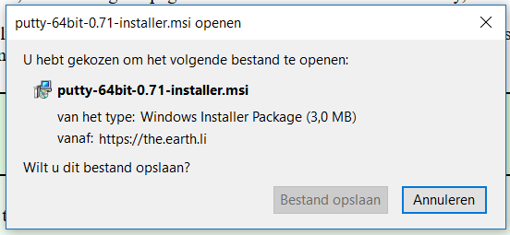

Select Next to continue

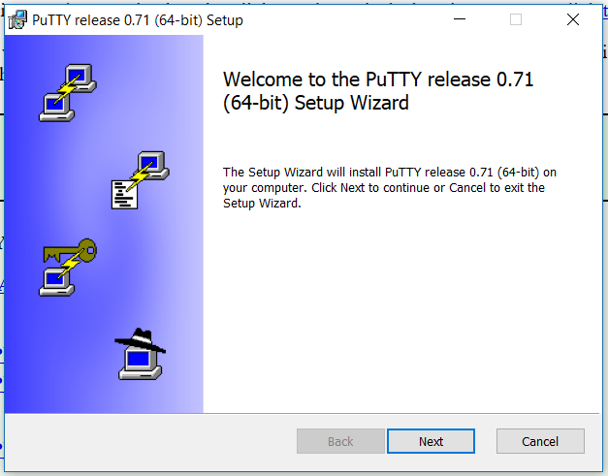

Change Destination Folder if needed and select Next to continue

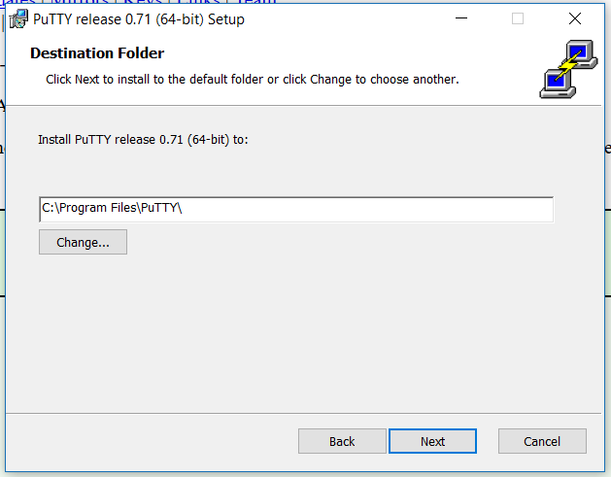

Select Install to continue

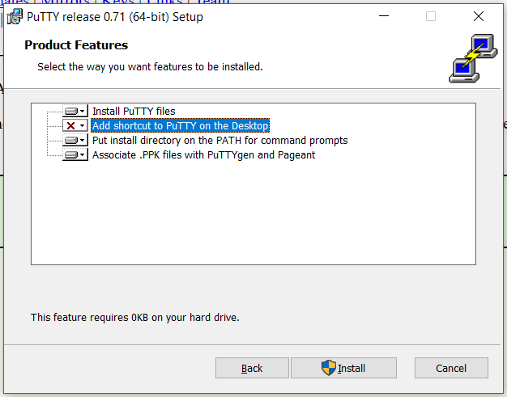

Select Finish to finalize installation

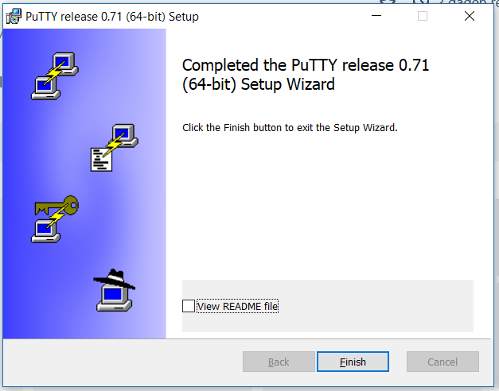

# Generate Public and Private Keys

Open PuTTYGen and Select “Generate”

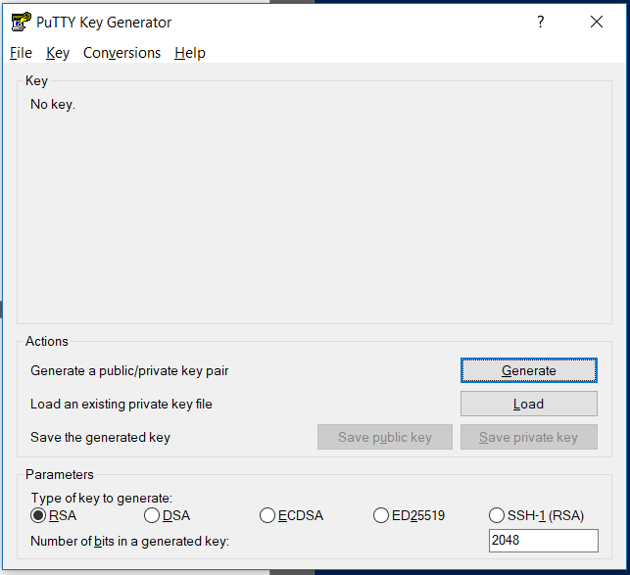

Move your cursor over the blank area until the keys are generated

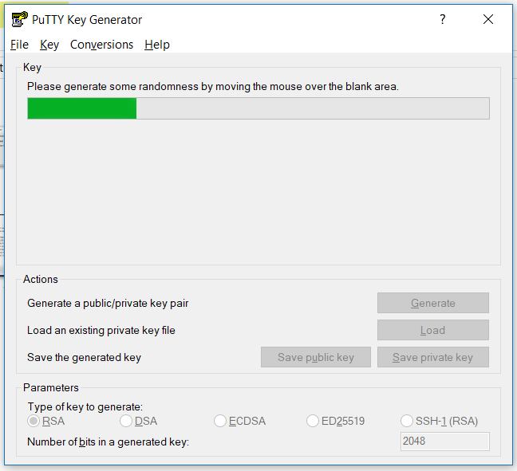

Enter and Confirm a passphrase (**you will need this later**) and Save the Private Key

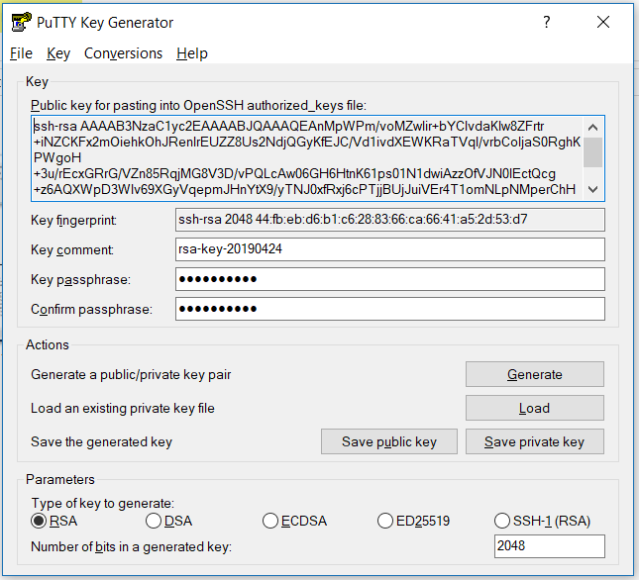

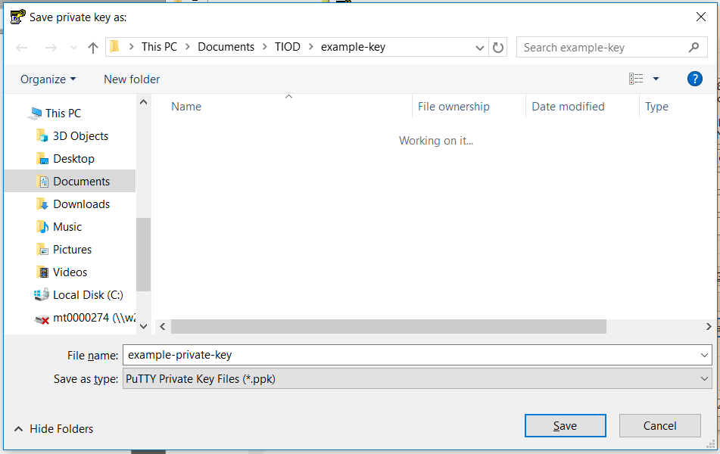

Copy the key and paste it in a New Text Document

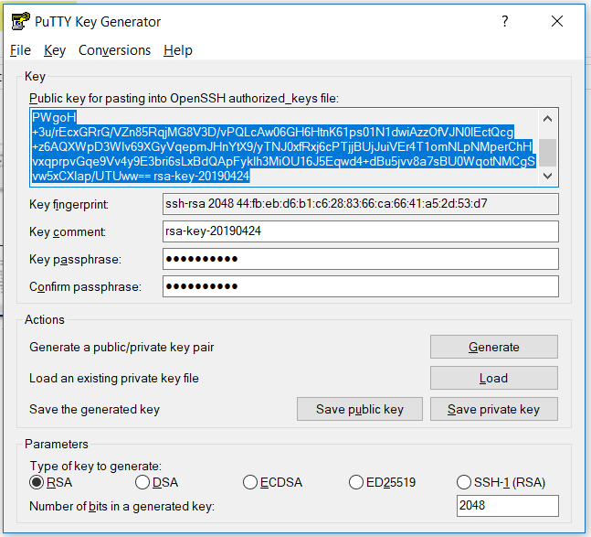

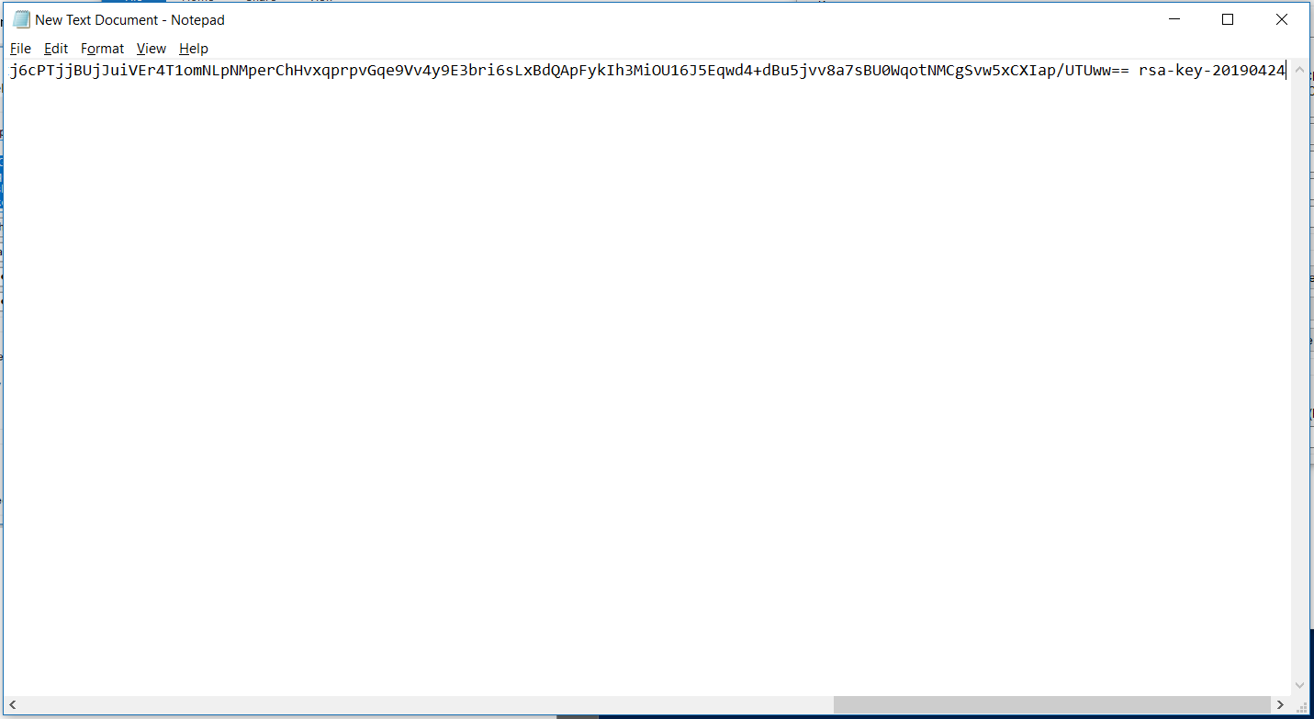

Select File > Save As and change **Save as type to All Files** and enter a file name followed by **.pub** and select Save

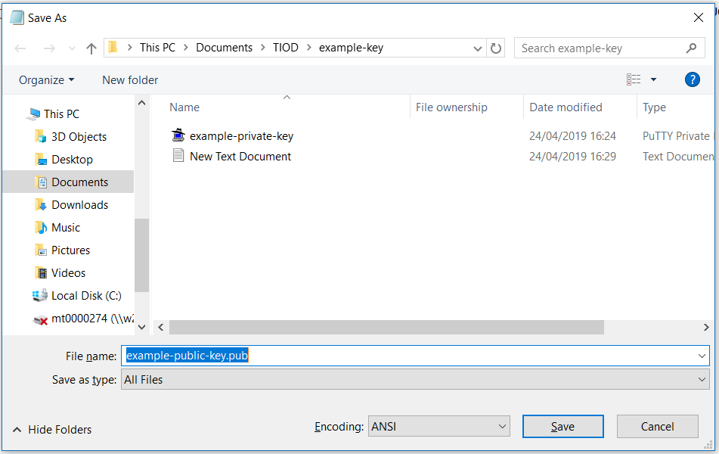

Email the newly created public.pub file to the KPN DSH Instructor, do **NOT** send the private key as this one is only for you.

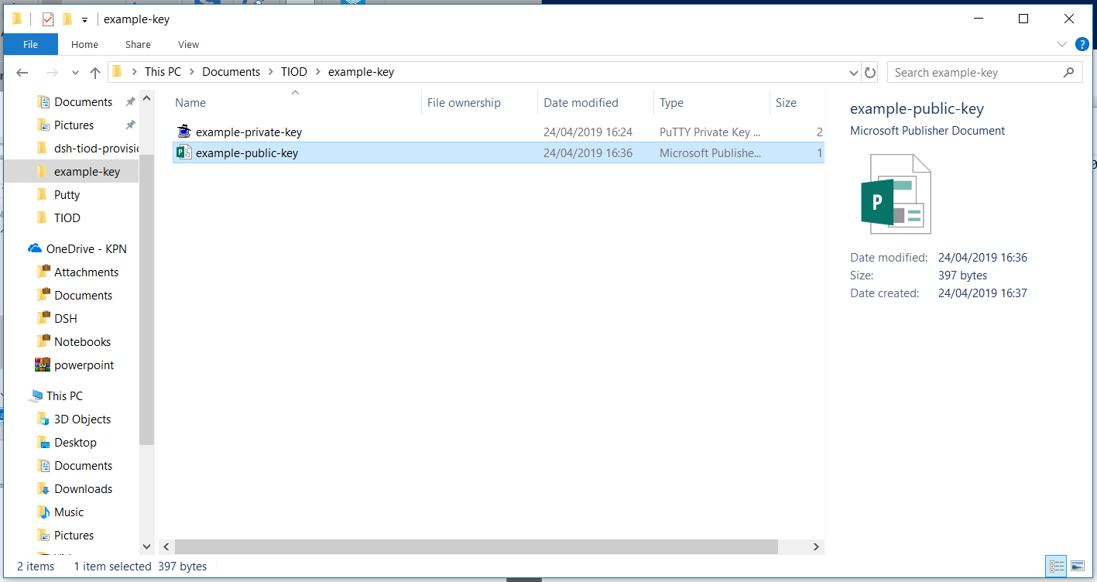

# Use PuTTY to Connect to the KPN DSH

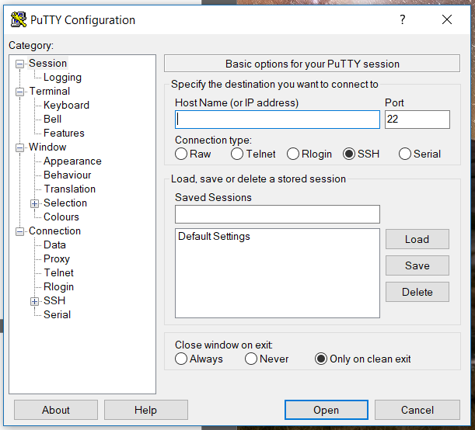

Open PuTTY and select Connection > SSH > Auth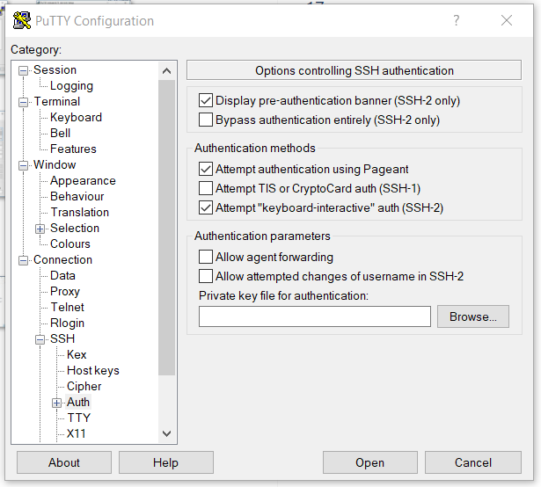

Select Browse.. and select and open your created private key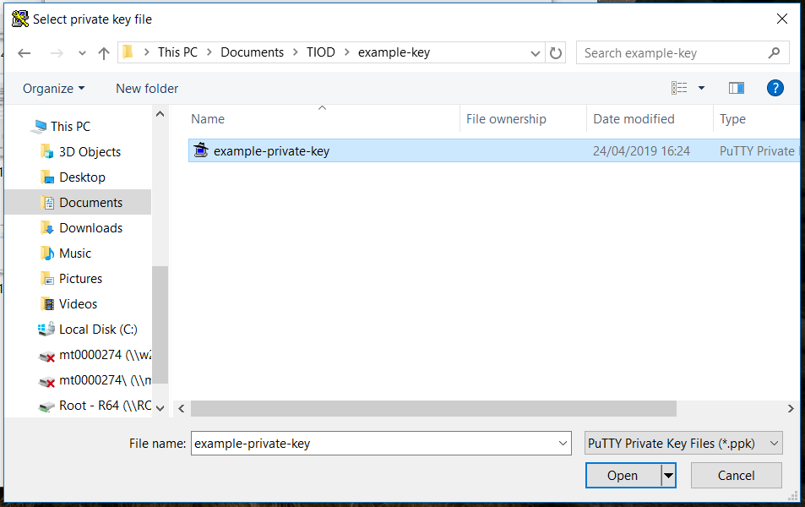

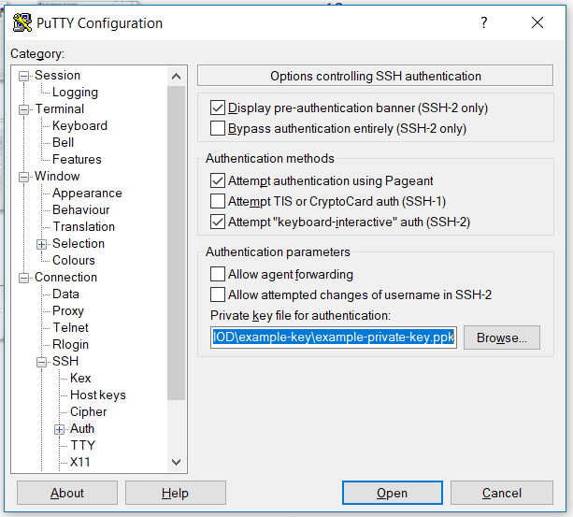

Select Session and fill in the IP address provided by the KPN DSH Instructor and Select Open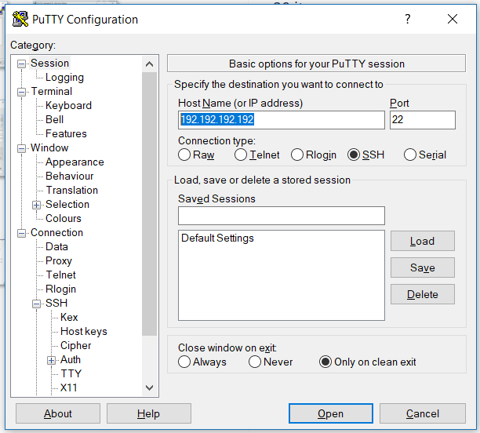

If you encounter the following screen, select Yes

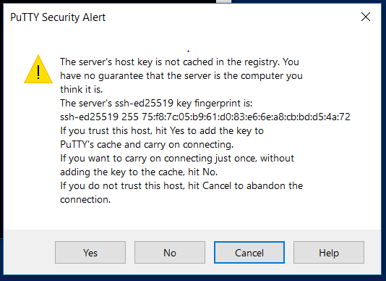

Enter **ubuntu** as login followed by your passphrase (entering passphrase is not shown) 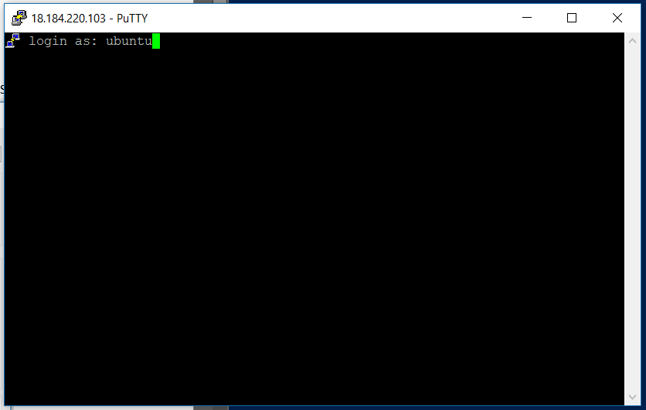

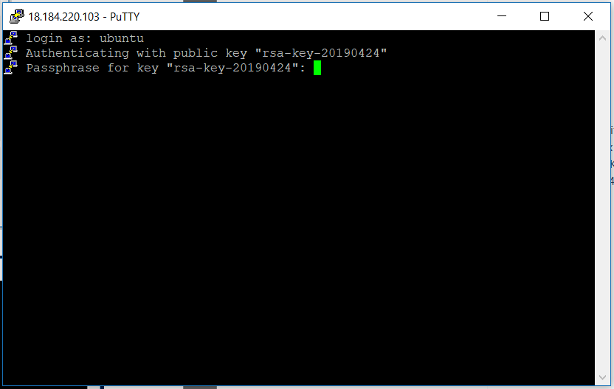

You are now ready to start the Tenant in One Day Training!